
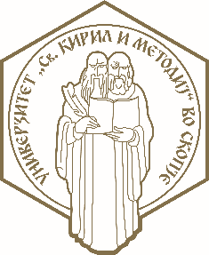

ERASMUS+ (STA)
Letter of confirmation for Erasmus+ Teaching Staff Mobility
in the Academic Year: ________

We hereby confirm that the below mentioned teacher from SS Cyril and Methodius University in Skopje (Erasmus code: MK SKOPJE 01), successfully accomplished the Erasmus Teaching Staff Mobility, agreed in her/his Teaching Programme.

Teacher’s name and surname:

Name and address of Host institution:

Erasmus code of host institution:

Dates of start and end of the mobility period /day/month/year/ (without travel days)
from : till:

Number of lecture hours:

Title(s) of lecture(s):

Other activities:

Confirmation of the Host institution:

Name of responsible person and signature:

_ _ _ _ _ _ _ _ _ _ _ _ _ _ _ _ _ _ _ _ _ _ _ _ _ Stamp:
Position of responsible person at the Host institution:

_ _ _ _ _ _ _ _ _ _ _ _ _ _ _ _ _ _ _ _ _ _ _ _ _ Date:_________________

